Activities for Long Term Care Settings

An individualized, well thought out activities program is at the heart of a quality life for residents (Cirillo, 2020). Activities are more than television and Bingo for your residents. Adult Family Homes (AFH) should identify each residents interest and needs, and involves the resident in an ongoing program of activities that is designed to appeal to his or her interests and to enhance the resident's highest practicable level of physical, mental, and psychosocial well-being (Cirillo, 2020).

**Activity Ideas**

**Music**. Having guests perform music for residents, using streaming applications or CD’s. Just make sure the music genre is appropriate for your residents age i.e. Frank Sinatra or Elvis Presly might be appropriate for some residents but if you have a house full of younger residents, some residents might enjoy Katy Perry or Deep Purple-know your demographic!

**Technology.** Computers, Ipads, tablets, virtual reality (VR) and game consoles are being used more frequently. Virtual visits can be done with loved ones or for doctors visits and now people can enjoy armchair travel through VR technology!

While no computer is necessary for a VR experience, special headsets such as [Oculus Go](https://www.oculus.com/go/?locale=en_US) and [Gear VR](https://www.samsung.com/global/galaxy/gear-vr/) are required. These can be purchased individually at many big-box stores or electronics retailers. Oculus Go and Gear VR are two of the most affordable and user-friendly VR headsets on the market.

Oculus Go is a standalone headset, so seniors simply slide it on and they’re immediately ready to get started. No wires, computers or any external devices at all are necessary.

Gear VR requires a Samsung Galaxy smartphone to function. The phone plugs directly into the front of the Gear VR headset, then functions virtually the same as Oculus Go.

From traveling around the world to exercising without even realizing it, these VR applications can be used by seniors and their loved ones to bring joy, provide a workout, allow an unplanned visit to another country or simply bond.

**Pet Therapy.** Rubbing a dog’s belly can make many of us feel all warm and fuzzy, and it’s particularly comforting to those who gave up pets when they moved into assisted living. Pet therapy programs that bring dogs in to snuggle with seniors can fill the gap. Spending time with animals [may even improve](https://www.cdc.gov/healthypets/health-benefits/index.html) a senior’s mental and physical health. (Pollock, 2020) Plus there are more than just therapy dogs! Horses, Alpacas and cats are used as therapy pets! (Pollock, 2020)

**Gardening.** Gardening is a superb way to go outside and stay active and connected to others. Digging in the dirt and planting and weeding can help seniors relax and unwind; not only that, but they also get to reap the benefits of their labor: beautiful flowers or tasty veggies. (Pollock, 2020)

**Board and Card Games.** Board games and card games are great for residents.

**Sensory Stimulation.** Keep a variety of hand lotions, spritzers, and hand sanitizing wipes on hand for impromptu hand-massaging activities. In addition, use fizzy bath tablets to slip into water for rejuvenating foot baths for your residents. To help with fidgeting, residents can use sensory balls and finger fidgets to engage with.

**Activity Boards.** Resident who may not want to or be able to participate in standard activities might benefit from activities boards. There are different types of boards. There are also activity lap pillows, blankets and water mats.

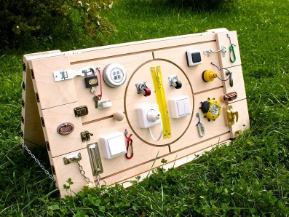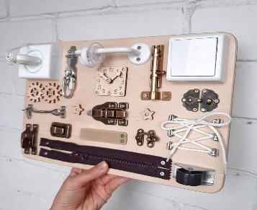

**Household Activities. H**aving a resident fold clothes and towels. If they can safely dust or do light housekeeping.

**Arts and Crafts.** Arts and crafts con include a variety of things. Sewing, making holiday decorations, coloring, coloring books, water-color and acrylic painting.

**Book Clubs.** Not only do book clubs support seniors’ efforts to stay sharp, [mentally alert](https://www.arborcompany.com/blog/top-6-memory-games-for-seniors) and in touch with the world, but they also have a huge social element.

**Movie Night.** Having the resident or residents pick a movie and watch together with movie snacks is always a great time.

**Field Trips and Excursion:**

Trips to the local library, mall or other outings are great mini-getaways for you residents. You can also jus go for scenic drives around your community- and it is always a bonus if your residents can share all the changes in the area and share history.

No matter what activities your AFH decides to participate in, the most important thing is to make sure the activity is appropriate for the resident. Ask your residents what activities they would like to participate in. Not all residents like group activities and their preference is to engage in solo activities.

References

Cirillo, A (2020). Activities for Nursing Homes and Assisted Living. Retrieved from

<https://www.verywellhealth.com/activities-for-nursing-homes-and-assisted-living-197773>

Pollock, K. (2020). 14 Activities for Elderly People That Aren’t Boring. Retrieved from

https://www.arborcompany.com/blog/14-activities-for-elderly-people-that-arent-boring